**Exercise - Multi Charts using QlikView**

**Student Name: Pulkit Agrawal Student Id: PXA180017**

**Date: 10/26/2018**

* 1. Paste the screenshot below of your sheet1 (Youth Employment Population)

**Answer**

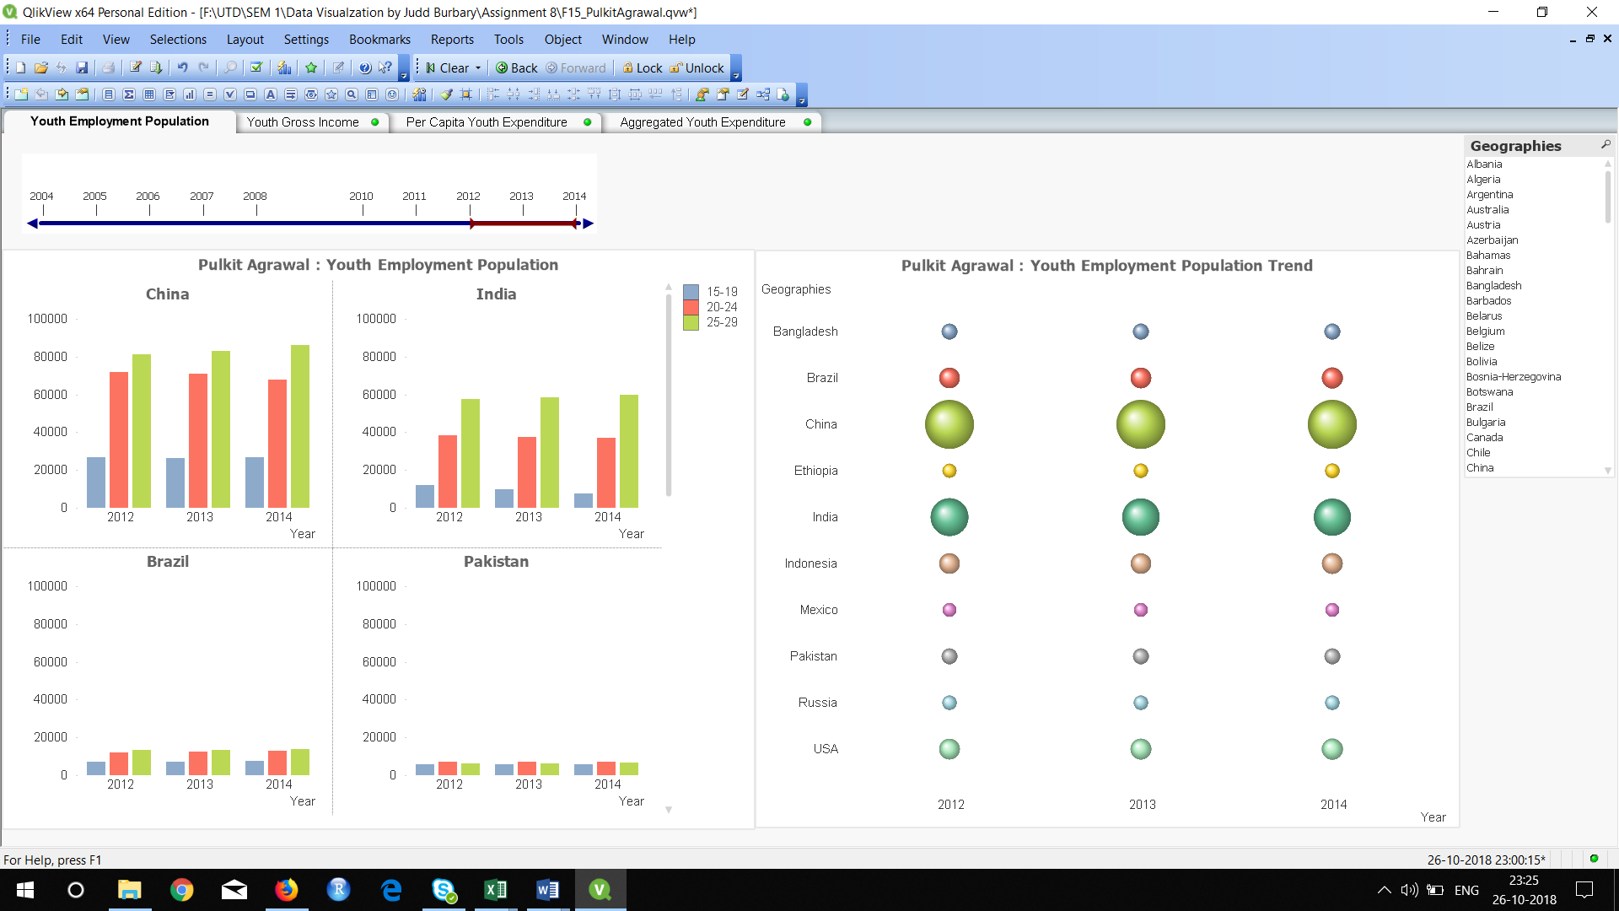

* 1. Which is the country having the highest youth employment population between 2004 through 2014? Paste the screen shot of the Youth Employment Population sheet below.

**Answer** China

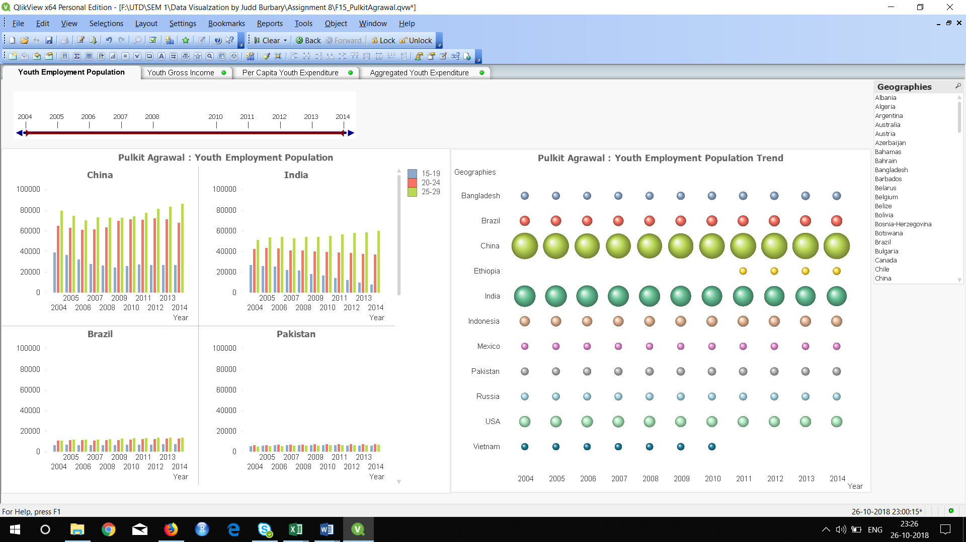

* 1. What is the trend between different age groups (15-19, 20-24, 25-29) do you notice in most of the countries from 2005 to 2014? What does the trend for Pakistan look like between these age groups?

**Answer** The trend observed across most of the countries is that the Youth employment population increases with increase in age group.

However, for Pakistan there is a decline in youth employment population for age group 25-29 compared to age group 20 -24. The highest employment population is found in age group 20 -24 and not 25 – 29

1. **Visualize Youth Gross Income**
   1. Paste the screenshot of your sheet

**Answer**

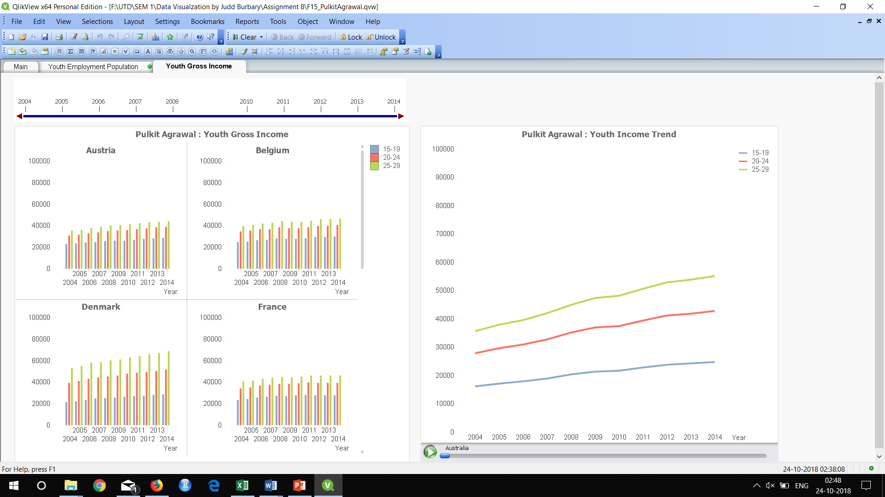

* 1. In which year was there a dip in the youth income in United Arab Emirates across all categories?

**Answer** 2009

1. **Visualize Youth Expenditure by Age Category**

* 1. Paste the screenshot of your sheet

Answer:

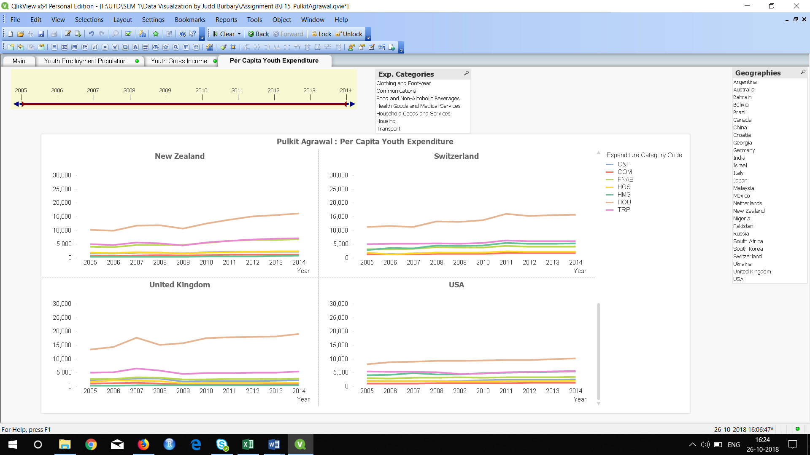

* 1. On Which commodity does the youth spend the most?

Answer: Housing

* 1. On which commodity does the youth in Switzerland spend the most in the year 2007?

Answer: Housing

1. **Visualize Youth Expenditure without Age Categories**
   1. Paste the screenshot of your sheet

Answer:

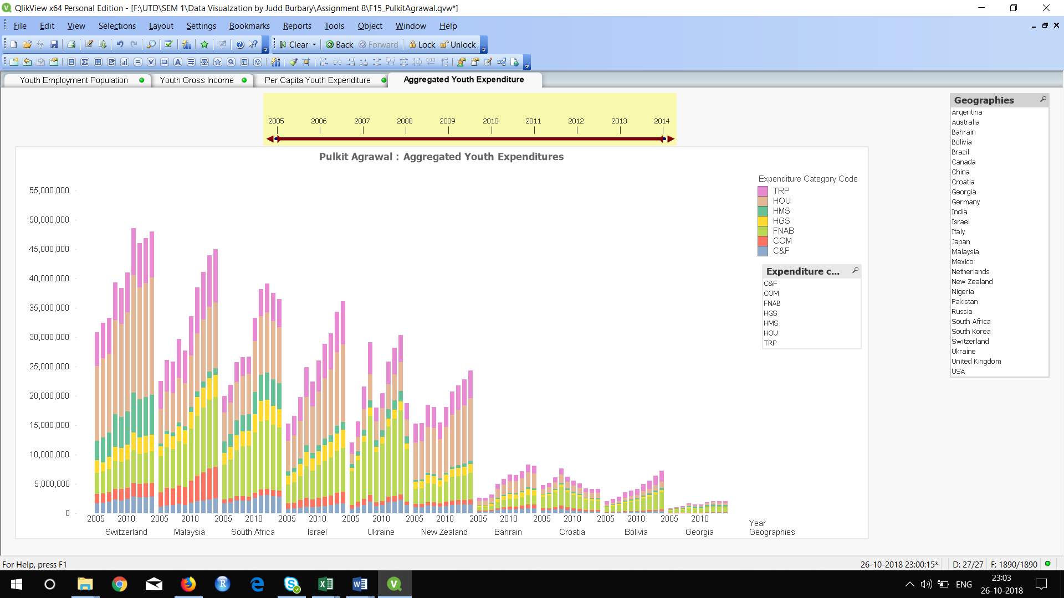

* 1. In which year did the youth spend on housing the most in Switzerland?

Answer: 2011

* 1. In which year(s) do you see sudden dip in the youth expenditure in Ukraine?

Answer: 2009 and 2014